Problem statement:
Missing snow chains in vehicle tires during winter mainly driving on snow surface will cause skidding and vehicle crash.
Solution:
Deep learning model that classifies if the tires in vehicles have chain or not and decide to allow the driver to drive further.
Procedure for this Deep Learning AI project:
Dataset collection:
- Collected wheels and tire images from google with and no chain and cropped the required zone.
- Stored in labeled folders as With and without chain. (Folder dataset method)
- Ran a simple python script to number the images and remove the duplicates in the folders.
Preprocessing:
- Followed the same size as mobilenet v2 and converted as arrays
- Used the same preprocessing methods from mobilenet v2 for image datasets and labeled accordingly.
- Stored the data and labels in separate lists.
- Labels are categorical data. So we used one hot encoding to convert it as numbers. LabelBinarizer()
- Split input and output for training and testing.
- Augmentation will help to reproduce the dataset with different angles, flip, shear etc. It will increase the dataset for learning.
Model creation:
- Used mobilenet v2 as base model (transferred the learning from mobilenet v2 since it has been trained already to recognize the circle, edges etc.
- Output of the base model is used as input to main model. Then CNN concept has been applied.
- Compiled the model using loss, optimizer and metrics.
- Fit the model for training inputs and validate the same with test input
Prediction:
Predict the output using test inputs

Classification report generated as evaluation metrics as it is classification problem.
Accuracy is 97%
Model is saved.
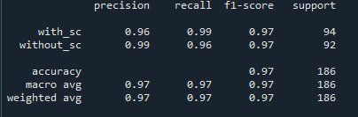
Same is plotted in graph as well.
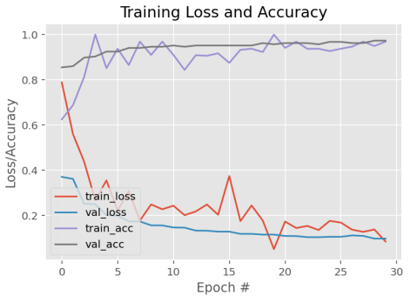
Deployment:
Used a pre-trained COCO – yolo based model from github to detect the wheel & tyre from the input image.
https://github.com/andBabaev/wheel-detector/releases/download/v1.0/yolov11n.pt
once the wheel & Tire is detected, that is sent to our new model to classify if the wheel has snow chain or not with bounding box with the decision taken.
Note: if video or CCTV footage is very fast and not clear due to the wheel rotation, model may not detect and classify correctly.

